Copyright Transfer Agreement

Jurnal Komunikasi require a formal written transfer of copyright from the author(s) for each article published. We therefore ask you to read, sign in the space provided, and return the complete form to us at supplementary files. Your cooperation is essential and appreciated.
Article entitled : Media Sosial sebagai Bagian dari Pembentukan Budaya Massa (Penggunaan Social Media Influencer sebagai Usaha Membangun Budaya Masyarakat Digital tentang Konsep Tubuh Ideal dan Kepercayaan Diri)
Corresponding author : Azizun Kurnia Illahi, Dewanto Putra Fajar, Muhammad Irawan Saputra
To be published in : Jurnal Komunikasi

COPYRIGHT TRANSFER
- I/We submit to JURNAL KOMUNIKASI for the above manuscript. I/We certify that the work reported here has not been published before and contains no materials the publication of which would violate any copyright or other personal or proprietary right of any person or entity.
- I/We hereby agree to transfer to Faculty of Communication, Universitas Tarumanagara the copyright of the above - named manuscript. I/We reserve the following: (1) All proprietary rights other than copyright such as patent rights. (2) The right to use all or part of this article in future works of our own such as in books and lectures.
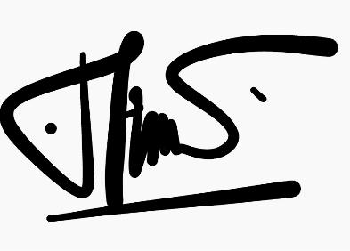
Azizun Kurnia Illahi.,S.I.Kom.,M.A

11 Juli 2020

Note :
If there are more than one author, only one signature will suffice

