Copyright Transfer Agreement

Jurnal Komunikasi require a formal written transfer of copyright from the author(s) for each article published. We therefore ask you to read, sign in the space provided, and return the complete form to us at supplementary files. Your cooperation is essential and appreciated.
Article entitled : Hariring Indung sebagai Media Komunikasi Ibu dan Anak Usia Dini
Corresponding author : Andalusia Neneng Permatasari
To be published in : Jurnal Komunikasi

COPYRIGHT TRANSFER
- I/We submit to JURNAL KOMUNIKASI for the above manuscript. I/We certify that the work reported here has not been published before and contains no materials the publication of which would violate any copyright or other personal or proprietary right of any person or entity.
- I/We hereby agree to transfer to Faculty of Communication, Universitas Tarumanagara the copyright of the above - named manuscript. I/We reserve the following: (1) All proprietary rights other than copyright such as patent rights. (2) The right to use all or part of this article in future works of our own such as in books and lectures.

Name and title of author

Bandung, 2 November 2020
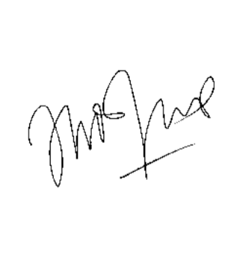
(Andalusia Neneng Permatasari)

Note :
If there are more than one author, only one signature will suffice

