THE INFLUENCE OF INTERNSHIP EXPERIENCE, SOCIAL SUPPORT, AND WORK MOTIVATION ON WORK READINESS
OF FEB STUDENTS OF UNIVERSITAS TARUMANAGARA

Vilysia¹, Joyce A. Turangan^{2*}

^{1,2} Faculty of Economics & Businesses, Universitas Tarumanagara, Jakarta Indonesia
Email: joycet@fe.untar.ac.id

*Corresponding Author

Submitted: 30-01-2024, Revised: 24-04-2024, Accepted: 11-07-2024

ABSTRACT
This study was conducted with the aim of knowing the effect of internship experience, social support and work motivation on the work readiness of FEB Tarumanagara University students. This study is a quantitative descriptive study with a cross-sectional method. The population in this study were all students of the Faculty of Economics and Business, Tarumanagara University. Sample selection was carried out using non-probability sampling method with purposive sampling sample selection technique. In this study, there are criteria for selecting samples such as having done an internship and being an active student at Tarumanagara University. The total sample in this study was 81 samples. From the data obtained, data processing will be carried out through SmartPLS software with the structural equation modeling (SEM) method of it. The result of the study shows through hypothesis testing that all the independent variable have a positive effect on Tarumanagara University students.

Keywords: Internship Experience, Social Support, Work Motivation, Work Readiness

1. INTRODUCTION

Human resources are the main factor in the ongoing activities of companies and organizations. In an organization, human resource management has a main focus on the development and training of human resources to create quality human resources. Every organization wants quality resources that are able to make a positive contribution to the organization.

Forming work readiness in oneself is necessary to face competition in the world of work. Nowadays, the competition to get a job is getting tighter. This competition arises because companies want to have a qualified and skilled workforce so that they can help the company progress. The great competitiveness to get a job requires each prospective worker to pay more attention to his or her skills to be able to compete with other individuals. To be able to compete in the world of work, prospective workers need work readiness in the form of knowledge, information and expertise.

Work readiness is an important thing to pay attention to because in entering the world of work prospective workers need to prepare everything thoroughly. The maturity that must be possessed is not only physical and mental maturity, but also the knowledge and experience that are suitable for carrying out work according to their choice (Muspawi et al, 2020). Based on data obtained from the national labor force survey with the benchmark of the unemployment rate based on age, the age when a person graduates from college is the second highest contributor to the statistics on the unemployment rate from 2021 to 2022.

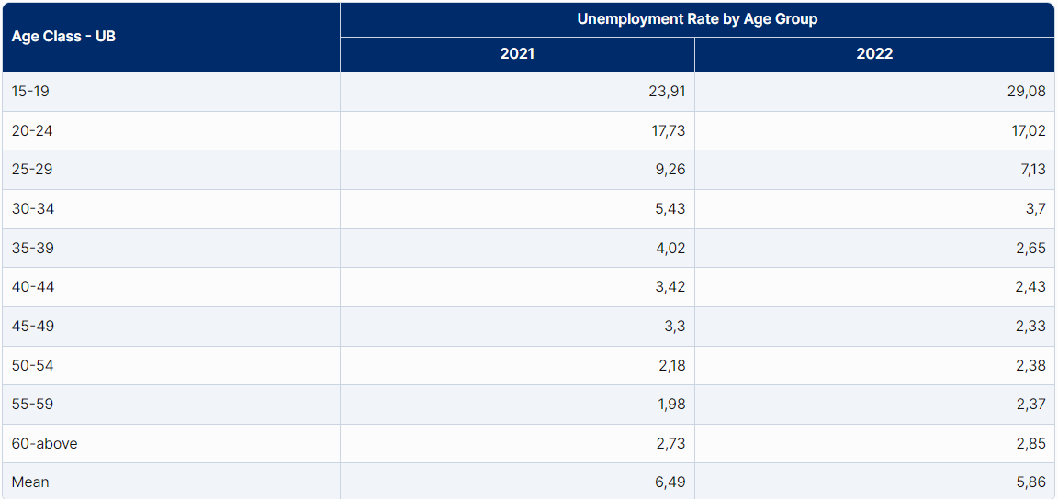
Figure 1. Unemployment Rate by Age
Source: National Labor Force Survey (Sakernas)

This fact proves that low productivity in job search and low quality and preparation of work make the unemployment rate still high. This fact can also be seen based on data on the open unemployment rate with the level of education as a benchmark. The university education level is at the fourth highest level from 2020 to 2022.

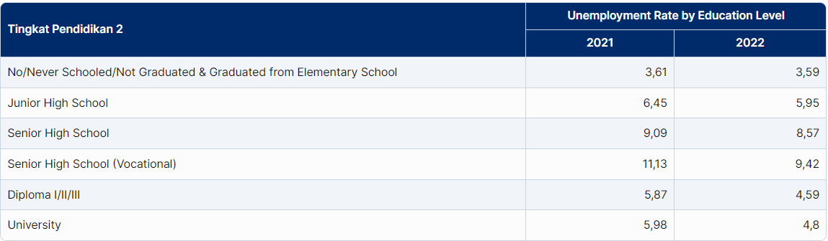
Figure 2. Unemployment Rate Based on Education Level
Source: National Labor Force Survey (Sakernas)

Work readiness is the main thing that needs to be prepared by prospective workers, especially students who will enter the professional workforce. Students can make preparations during the lecture period by participating in programs organized by the university such as internship programs and theories related to the world of work. Work readiness is basically influenced by factors that come from within oneself and from outside oneself. The biggest influence on a person's level of work readiness is determined by himself, other factors that are guilty from outside himself are only supporting. However, these external factors also need to be considered to help maximize the factors within. Factors included in oneself include: intelligence, skills and motivation. While factors that come from outside oneself include: social support, work experience, and job information. Work readiness will form by itself when the support provided from outside oneself is balanced with the initiative within oneself to want to prepare for work.

Based on research conducted by Sofa et al (2020), several factors mentioned earlier have a significant influence. Internal and external factors that are well prepared by someone will lead to mature work readiness. This research is in line with research conducted by Yuliana & Yuniarsih (2018) and Mustari & Armanu (2021). Internship experience has a positive and significant influence on work readiness. Internship experience provides great benefits for students because internships that have been carried out in the world of work can provide experiences that shape students' personalities to be ready to work and have expertise in accordance with their fields. This research is also in line with research conducted by Tentama and Riskiyana (2020). Social support has a positive and significant influence on work readiness. Social support contributes to the career development process which is a source of strength for students in shaping work readiness. The social support received helps students in finding information related to career knowledge that is relevant to the needs of the world of work.

This research is in line with research conducted by Mutoharo and Rahmaningtyas (2019). Work motivation has a positive and insignificant influence on work readiness. Work motivation in the study did not have an influence on work readiness because the enthusiasm and drive to work was still not enough to improve work readiness.

The collected data will then be analyzed using the Partial Least Square-Structural Equation Modeling (PLS-SEM) approach with the SmartPLS 4.0 software. The research involves data analysis, including test for validity and reliability, multicollinearity test,determination coefficients (R² ), predictive relevance (Q² ),and hypothesis testing.

The research instrument in this study uses a questinnaire for data collection. The measurement scale used in this research is an ordinal scale, in the form of a likert scale, to measure agreement or dissagreement by respondents with questionnaire statements, divided into five score categories :1 = strongly disagree, 2 = disagree, 3 = neutral, 4 = agree, 5 = strongly agree.

Internship Experience
Taylor (1988) suggests a definition related to internship experience as work experience obtained by students with relevant careers before graduating from an academic program. Meanwhile, according to Chaplin (2006), internship experience is things that are obtained during the process of practice or training outside of learning activities obtained in the form of knowledge and skills that aim to gain experience before entering the real world of work.

According to Polonsky and Waller (2018) internship experience is an opportunity for students to gain an understanding of a profession in a particular industry to develop practical skills and experience the real world of work.

Internship experience is an opportunity for students to develop their skills. As stated by Grobman (2021) internship experience is an out-of-class learning opportunity designed to provide practical experience that allows students to apply practical theory in the workplace. Meanwhile, according to Bailey and Hughes (2005) internship experience is a learning process that occurs in the workplace where students gain learning through observation and active participation in daily activities in the world of work.

Based on these five definitions, researchers can conclude that internship experience is an experience gained outside of learning activities carried out by students in the form of practicing theory by participating directly in daily activities in the workplace.

Social Support
According to Cohen (2000) social support is a real and perceivable interaction between people that can increase respect and a sense of belonging. Taylor (2011) also argues the same thing regarding social support. According to Taylor (2011) social support is a social network that makes a person help each other and is obliged to feel loved and love, valued and appreciate.

Meanwhile, according to House (1981) social support is an interpersonal transaction involving emotional attention, instrumental assistance, information and advice.

Weiss (1974) defines social support as a pattern of intense human resource interactions from the closest people in the environment. Connecting with the definition put forward by Weiss (1974), according to Arindawanti and Izzaati (2021) social support is a perception of the availability of support resources obtained from others.

Based on those definitions, researchers can conclude that social support is a real interaction that occurs in a social network related to emotional attention, instrumental assistance, information and advice that makes a person feel loved and love as well as valued and appreciated.

Work Motivation
Work motivation is a process that initiates and maintains performance to achieve certain goals (Clark, 2003). Meanwhile, according to Vijande (2022) work motivation is a condition that encourages someone to want to do an activity to achieve their goals.

Work motivation is related to the process as said by Luthans (1998) that work motivation is a process that generates energy and directs and maintains behavior and performance.

According to Faslah and Savitri (2013) work motivation is an effort made by someone in order to achieve goals at work that are individual in nature.

Work motivation itself can be in the form of encouragement as said by Adinda, et al (2023) that work motivation is the drive or enthusiasm that moves a person to do work effectively to achieve company goals.

Likewise, as stated by Darmawan (2007) work motivation is an encouragement to direct subordinates to work productively to realize predetermined goals.

Based on these six definitions, researchers can conclude that work motivation is an effort to initiate and maintain performance that makes a person encouraged to carry out activities productively.

Work Readiness
Work readiness according to Muspawi, et al (2020) is a condition of physical maturity, mental maturity and learning experience of a person to do a job according to his choice.

Work readiness is the condition of an individual before starting work as Nasution (2004) says work readiness is a condition that precedes the work activity itself without this, the work will not happen.

According to Slameto (2010) work readiness is the overall condition of a person that makes him ready to respond or answer to a situation.

Meanwhile, according to Caballero and Walker (2010) work readiness is the extent to which graduates are considered to have attitudes and attributes that show they are ready to succeed in the work environment.

Work readiness is a condition when an individual is ready to work, as is the definition of work readiness put forward by Clark (2013) work readiness is an individual who is ready to work has the basic skills needed to qualify for a job determined through job analysis or job profile.

Based on these five definitions, researchers can conclude that work readiness is a condition that precedes all processes that create physical and mental maturity in a person to enter the world of work.

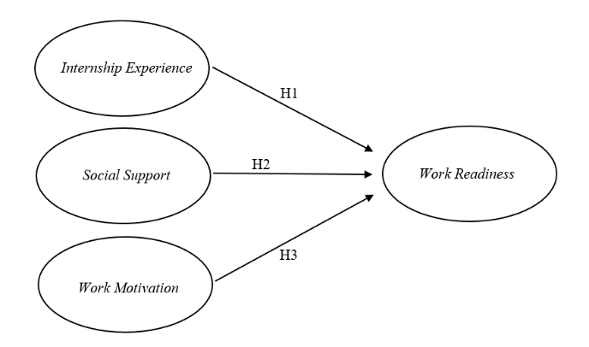
Figure 3. Research Model

H1: Internship experience has a positive influence on the work readiness of Tarumanagara University economics and business faculty students.
H2 : Social support has a positive influence on the work readiness of Tarumanagara University economics and business faculty students.
H3 : Work motivation has a positive influence on the work readiness of Tarumanagara University economics and business faculty students.

3. RESULTS AND DISCUSSIONS

Validity Analysis
This research employs the Structural Equation Modeling (SEM) technique in the analysis of validity, which comprises convergent validity (Average Variance Extracted (AVE) and outer loadings) and discriminant validity (cross-loading).

Based on the validity analysis results in Table 1, it is indicated that each research variable is valid. The Average

Variance Extracted (AVE) results are greater than 0.50 (> 0.50). The internship experience variable has an ave value of 0,500; the social support is 0,531; the work motivation is 0.517, and work readiness is 0,512

Tabel 1. Average Variance Extracted
Variable | Average Variance Extracted (AVE)
Internship Experience | 0.500
Social Support | 0.531
Work Motivation | 0.517
Work Readiness | 0.512

The validity analysis result in table 2 indicate that each research variable is valid. The outer loading result are greater than 0.50 (>0.50).

Table 2. Outer Loadings
 | Outer Loadings
IE1 ← IE | 0.515
IE2 ← IE | 0.798
IE4 ← IE | 0.807
IE5 ← IE | 0.728
IE6 ← IE | 0.681
IE7 ← IE | 0.797
IE8 ← IE | 0.728
IE9 ← IE | 0.537
SS1 ← SS | 0.734
SS2 ← SS | 0.756
SS3 ← SS | 0.760
SS6 ← SS | 0.661
WM3 ← WM | 0.721
WM5 ← WM | 0.730
WM6 ← WM | 0.777
WM7 ← WM | 0.643
WR3 ← WR | 0.709
WR6 ← WR | 0.773
WR7 ← WR | 0.635
WR8 ← WR | 0.741
WR9 ← WR | 0.609
WR10 ← WR | 0.806

The validity analysis result in table 3 indicate that each research variable is valid. The indicator values are higher for each construct compared to the indicator of other constructs.

Table 3. Cross Loadings
 | IE | SS | WM | WR
IE1 | 0.515 | 0.357 | 0.343 | 0.423
IE2 | 0.798 | 0.504 | 0.436 | 0.620
IE4 | 0.807 | 0.513 | 0.435 | 0.612
IE5 | 0.728 | 0.487 | 0.334 | 0.483
IE6 | 0.681 | 0.592 | 0.514 | 0.549
IE7 | 0.797 | 0.620 | 0.481 | 0.672
IE8 | 0.728 | 0.458 | 0.381 | 0.474
IE9 | 0.537 | 0.293 | 0.349 | 0.458
SS1 | 0.482 | 0.734 | 0.364 | 0.519
SS2 | 0.540 | 0.756 | 0.452 | 0.521
SS3 | 0.638 | 0.760 | 0.285 | 0.560
SS6 | 0.314 | 0.661 | 0.349 | 0.444
WM3 | 0.473 | 0.468 | 0.721 | 0.428
WM5 | 0.330 | 0.313 | 0.730 | 0.434
WM6 | 0.480 | 0.457 | 0.777 | 0.488
WM7 | 0.397 | 0.145 | 0.643 | 0.363
WR3 | 0.577 | 0.561 | 0.482 | 0.709
WR6 | 0.590 | 0.472 | 0.480 | 0.773
WR7 | 0.467 | 0.371 | 0.390 | 0.635
WR8 | 0.595 | 0.547 | 0.457 | 0.741
WR9 | 0.397 | 0.455 | 0.317 | 0.609
WR10 | 0.642 | 0.588 | 0.426 | 0.806

Reliability Analysis
The result of the reliability analysis in table 4 state that each research variable are reliable. The composite reliability result are greater than 0.70(>0.70).

Table 4. Reliability Analysis
Variable | Composite Reliability
Internship Experience | 0.887
Social Support | 0.819
Work Motivation | 0.810
Work Readiness | 0.862

Multicollinearity Test

The results of the multicollinearity test in this study are in table 5. based on the results shown in the table below, between the variables used in this study there is no multicollinearity because it has a VIF value of less than 5 (<5).

Table 5. Multicollinearity Test
 | VIF
Internship Experience → Work Readiness | 2.236
Social Support → Work Readiness | 1.948
Work Motivation → Work Readiness | 1.558

Coefficient of Determination (R² )
Based on the results of testing the coefficient of determination (R-Square), it is known that the coefficient of determination (R-Square) on the work readiness variable is 0.673 or 67.3%. This indicates that the internship experience, social support and work motivation variables have a moderate influence in explaining the work readiness variable, which is 67.3%. While the remaining influence of 32.7% is explained by other variables outside of this study.

Predictive Relevance (Q² )
The results of the predictive relevance analysis in this study amounted to 0.633. These results indicate that the relationship between the variables used in this study is considered relevant to measuring the research model created in this study. This variable is considered relevant because it has a predictive relevance value (Q² ) greater than 0 (>0).

Hypothesis Test
The results of the first hypothesis test can be seen in table 6, showing that internship experience has a positive influence with a path coefficient value of 0.460. Internship experience also has a significant effect with a p-value of 0.000 which is below the maximum limit of 0.05 (<0.05). The f-square value obtained by internship experience is 0.289, which means that internship experience has a moderate effect on the work readiness of Tarumanagara University economics and business faculty students. So it can be concluded that H1 in this study is accepted.

Based on the results of the first hypothesis test, this study is in line with research conducted by Yuliana and Yuniarsih (2018). Internship experience provides great benefits for students because internships that have been carried out in the world of work can provide experiences that shape students' personalities to be ready to work and have expertise in accordance with their fields. Similar to research conducted by Mustari and Armanu (2021), internship experience is carried out with the aim of increasing the ability and skills possessed for work.

In this study, students had good preparation and implementation of internships. The internship experience gained in the form of knowledge, skills, and work creativity makes students feel facilitated in the process of forming work readiness in themselves.

Table 6. First Hypothesis Test Results
Variable | Value | Description
Internship Experience → Work Readiness | β = 0.460 | Positive
Internship Experience → Work Readiness | p-value = 0.000 | Significant
Internship Experience → Work Readiness | = 0.289 | Has a moderate effect

The results of the second hypothesis test can be seen in table 7, showing that social support has a positive influence with a path coefficient value of 0.297. Social support also has a significant effect with a p-value of 0.001 which is below the maximum limit of 0.05 (<0.05). The f-square value obtained by social support is 0.139, which means that social support has a small effect on the work readiness of Tarumanagara University economics and business faculty students. So it can be concluded that H2 in this study is accepted.

Based on the results of the second hypothesis test, this study is in line with research conducted by Tentama and Riskiyana (2020). Social support contributes to the career development process which is a source of strength for students in shaping work readiness. The social support received helps students in finding information related to career knowledge that is relevant to the needs of the world of work.

In this study, students have someone who can provide support to them. This helps students to undergo the career development process, especially in shaping work readiness.

Table 7. Second Hypothesis Test Results
Variable | Value | Description
Social Support → Work Readiness | β = 0.297 | Positive
Social Support → Work Readiness | p-value = 0.001 | Significant
Social Support → Work Readiness | = 0.139 | Has a small effect

The results of the third hypothesis test can be seen in table 8, showing that it has a positive influence with a path coefficient value of 0.183. Social support has an insignificant effect with a p-value of 0.063 which is above the maximum limit of 0.05 (<0.05). The f-square value obtained by work motivation is 0.066, which means that work motivation has little effect on the work readiness of students of the faculty of economics and business at Tarumanagara University. So it can be concluded that H3 in this study is accepted.

Based on the results of the third hypothesis test, this study is in line with research conducted by Mutoharo and Rahmaningtyas (2019). Work motivation in the study did not have an influence on work readiness because the enthusiasm and drive to work was still not enough to increase work readiness.
In this study, work motivation cannot have a significant effect on students' work readiness because students feel that the motivation they have does not make them ready to work. Even though students have encouragement from the environment to work, it does not necessarily mean that they themselves have work readiness.

Table 8. Third Hyphothesis Result
Variabel | Nilai | Description
Work Motivation → Work Readiness | β = 0.183 | Positive
Work Motivation → Work Readiness | p-value = 0.063 | Not Significant
Work Motivation → Work Readiness | = 0.066 | Has a small effect

The result of the hypothesis testing are depicted in figure 1 within the bootstrap model as follows :

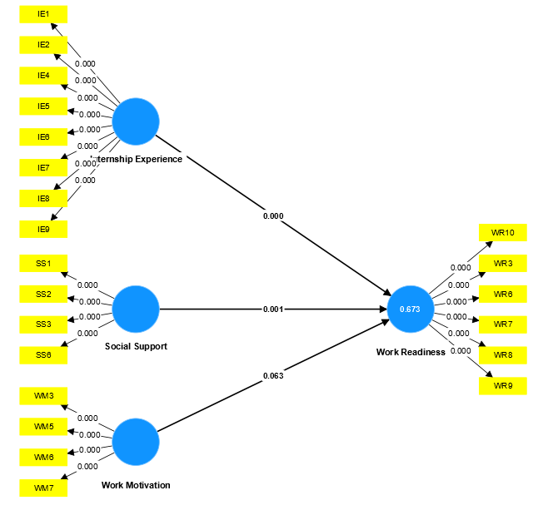
Figure 4. Bootstraping Result

4. CONCLUSIONS AND SUGGESTIONS

Based on the results of testing and analysis conducted in this study, it can be concluded that internship experience and social support have a positive and significant influence while work motivation has a positive and insignificant influence on the work readiness of FEB students of Tarumanagara University.

This research is expected to be a reference for future studies to conduct research on work readiness using other variables that have not and are not used in this study. In addition, future research is expected to expand the scope of the research area such as all Tarumanagara University students to other students outside Tarumanagara University. For future research that wants to examine work readiness, it is recommended to increase the sample used in the study, so as to get results that are more representative of the research population.

ACKNOWLEDGMENT

The author would like to express heartfelt gratitude to all parties who have participated during the preparation of this research journal article, especially to: the Supervising Lecturer, the Dean of the Faculty of Economics and Business at Tarumanagara University, the Head of the Undergraduate Management Program at Tarumanagara University, all the respondents who contributed to supporting the author during the data collection process, and all other individuals who cannot be mentioned individually.

REFERENCES

Adinda, T. N., Firdaus, M. A., & Agung, S. (2023). Pengaruh motivasi kerja dan disiplin kerja terhadap kinerja karyawan. Indonesian Journal of Innovation Multidisipliner Research, 1(3), 134-143.
Arindawanti, R. A. D. dan Izzati, U. A. (2021). Hubungan antara dukungan sosial dengan subjective well-being pada karyawan bagian produksi. Jurnal Penelitian Psikologi Vol 8 No.4.
Bailey, T., Hughes, K., & Barr, T. (2000). Achieving scale and quality in school-to-work internships: Findings from two employer surveys. Educational Evaluation and Policy Analysis, 22(1), 41-64.
Caballero, C., & Walker, A. (2010). Work readiness in graduate recruitment and selection: A review of current assessment methods. Journal of Teaching and Learning for Graduate Employability, 1(1), 13 – 25
Clark, H. (2013). Work readiness standards and benchmarks: the key to differentiating america's workforce and regaining global competitiveness. ACT, Inc.
Clark, R. E. (2003). Fostering the work motivation of individuals and teams. Performance improvement, 42(3), 21-29.
Didit Darmawan. (2007). Strategi pengembangan sumber daya manusia. Pustakamedia
Faslah, R., & Savitri, M. T. (2013). Pengaruh motivasi kerja dan disiplin kerja terhadap produktivitas kerja pada karyawan pt. Kabelindo murni, Tbk. Jurnal Pendidikan Ekonomi Dan Bisnis (JPEB), 1(2), 40-53.
Grobman, G. M. (2021). An introduction to the nonprofit sector: A practical approach for the 21st century. White Hat Communications.
House. (1981) Work stress and social support.reading, MA: Addison-Wesley.
Luthans, F. (1998). Organisational Behaviour. 8th ed. Boston: Irwin McGraw-Hill.
Muspawi, M., & Lestari, A. (2020). Membangun kesiapan kerja calon tenaga kerja. Jurnal Literasiologi, 4(1).
Mustari, A. M. I. (2021). Pengaruh pengalaman magang dan minat kerja terhadap kesiapan kerja (studi pada mahasiswa fakultas ekonomi dan bisnis Universitas Brawijaya). Jurnal Ilmiah Mahasiswa FEB, 9(2).
Mutoharoh, A. K., & Rahmaningtyas, W. (2019). Pengaruh praktik kerja industri, lingkungan keluarga, bimbingan karier dan motivasi kerja terhadap kesiapan kerja. Sains: Jurnal Manajemen dan Bisnis, 12(1), 38-59.
Nasution. (2004). Sosiologi Pendidikan, Jakarta: Bumi Aksara.
Polonsky, M. J., & Waller, D. S. (2018). Designing and managing a research project: A business student's guide. Sage publications.
S. Cohen, L. G. Underwood, and B. H. Gottlieb (2000), Social support measurement and intervention: A guide for health and social scientists. New York: Oxford University Press.
Santos Vijande, M. L., López-Sánchez, J. Á., Pascual Fernández, P., & Rudd, J. M. (2021). Service innovation management in a modern economy: Insights on the interplay between firms’ innovative culture and project level success factors. Technological Forecasting and Social Change, 165.
Slameto. (2010). Belajar dan faktor-faktor yang mempengaruhinya (revisi). Jakarta: Rineka Cipta.
Sofa, F. M., Suryani, N., & Rahmawati, F. D. (2020). The influence of industrial work practice (internship), corporate world information, and motivation of entering corporate world towards working readiness of students at class XII office administration department in SMK Negeri 2 Temanggung 2018/2019. KnE Social Sciences, 702-719.
Taylor, M.S. (1988), “Effects of college internships on individual participants”, Journal of Applied Psychology, Vol. 73, pp. 393-401.
Taylor, S. E. (2011). Social support: A review. The Oxford handbook of health psychology, 1, 189-214.
Tentama, F., & Riskiyana, E. R. (2020). The role of social support and self-regulation on work readiness among students in vocational high school. International Journal of Evaluation and Research in Education, 9(4), 826-832.
Weiss, R. S. (1974). The provision of social relationship. In Z. Rubin (Ed.), Doing unto others (pp. 17–28).New Jersey: Prentice-Hall, Inc.
Yuliani, L., & Yuniarsih, T. (2019). Influence of industrial work practices and learning achievements on students work readiness. In 1st International Conference on Economics, Business, Entrepreneurship, and Finance. Atlantis Press.

